**Project Title:** Digital Cricket Stadium Scoreboard



**Submitted by:**

1. **Farwa Imran (NUM-BSCS-2024-22)**
2. **Barira Ijaz (NUM-BSCS-2024-20)**
3. **Waseem-Ullah (NUM-BSCS-2024-78)**

**CSC-140 Digital Logic Design**

**SPRING - 2025**

**Department of Computer, Namal University Mianwali**

1. **Project Description:**

The **Digital Cricket Scoreboard** project is designed to display the live match status of a cricket game by showing the **Runs**, **Overs**, and **Wickets** using seven-segment displays. Each category is independently managed and updated using **push buttons**. The system utilizes the **74160 synchronous decade counter** to count the values in Binary Coded Decimal (BCD) format. These BCD outputs are then decoded through **7447 BCD-to-7-segment decoder ICs** to drive the display units.

For **Runs**, the display can show two digits (00–99), allowing tracking of high scores. The complete circuit was tested through **Proteus simulation** and also assembled on a **breadboard**. The project gave us hands-on experience in designing digital systems using counters, decoders, and display modules, along with the implementation of real-time control logic for sports applications.

Bottom of Form

1. **Components Used:**

* **74160** – Synchronous Decade Counter (used for Runs, Overs, and Wickets counting)
* **7447** – BCD to 7-Segment Decoder/Driver
* **7-Segment Displays** – Common Anode, used to display numerical values
* **Push Buttons** – For manually incrementing Runs, Overs, and Wickets
* **Resistors** – Used with 7-segment displays and buttons for current limiting
* **Breadboard** – For circuit Implementation
* **Connecting Wires** – Also For physical circuit implementation
* **Proteus Software** – For digital logic simulation and testing
* **7805 Voltage Regulator** – To provide a stable +5V power supply to the circuit
* **Power Supply** – 9V battery or adapter (input to 7805), +5V output)
* **Capacitors** – 10µf

1. **Steps to Assemble Components:**

**Step 1: Power Supply Setup**

• Place the 7805 voltage regulator on the breadboard.  
• Connect a 9V battery or adapter to the input (Pin 1) of the 7805.  
• Connect Pin 2 (GND) to the ground rail.  
• Connect Pin 3 (Output) to the +5V rail.  
• Place one capacitor (10µF) between Pin 1 and GND, and another between Pin 3 and GND.

**Step 2: Place the ICs**

• Insert one 74LS160 counter and one 7447 decoder IC on the breadboard (for each digit).  
• Connect Pin 16 of each IC to +5V and Pin 8 or 7 to GND.

**Step 3: BCD Counter to Decoder Connections**

• Connect 74LS160 Q0–Q3 (Pins 3, 4, 5, 6) to 7447 A–D (Pins 7, 1, 2, 6).

**Step 4: Decoder to 7-Segment Display**

• Connect 7447 output pins (9–15) to the 7-segment display pins (a–g) via 330Ω resistors.  
• Connect the common cathode pin of the display to GND.

**Step 5: Button for Counting**

• Connect a push button between +5V and Pin 1 (CLK) of the 74LS160.  
• Place a 10kΩ resistor from Pin 1 to GND (pull-down).

**Step 6: Reset and Load Pins**

• Tie CLR (Pin 9) and LOAD (Pin 10) of 74LS160 to +5V.

**Step 7: Cascading Counters**

• To count double digits (like 27 runs), connect the carry-out (Pin 14) of the first 160 to the clock input (Pin 1) of the next.

**Step 8: Repeat Setup**

• Repeat the above for WICKETS, OVERS, BALLS using additional ICs and displays.

1. **Proteus Simulation Screenshot:**

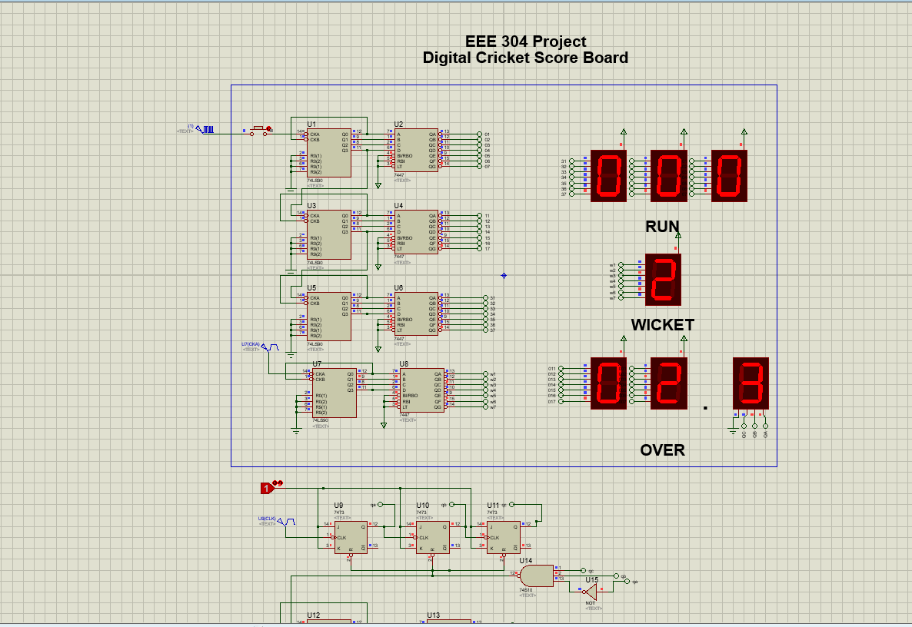

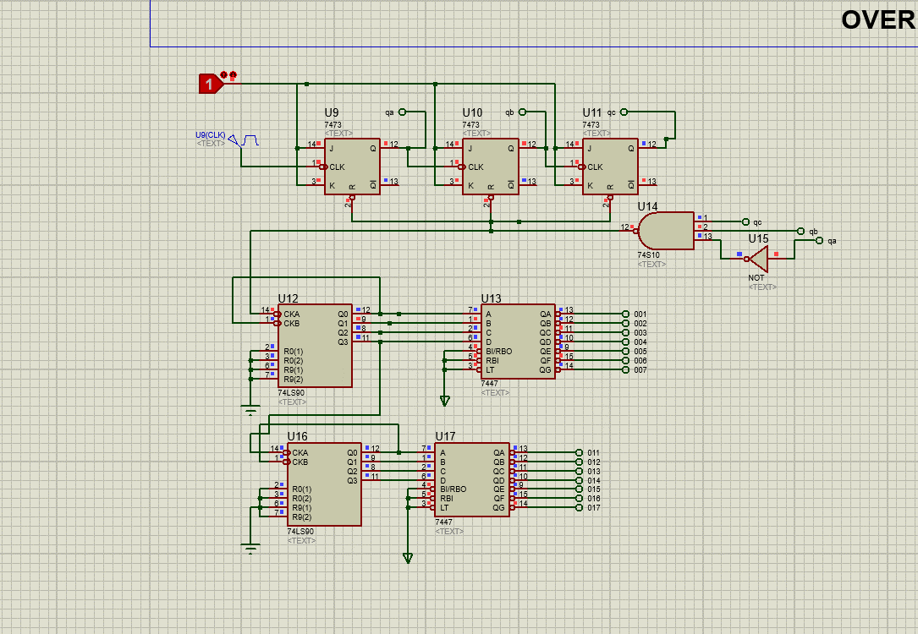

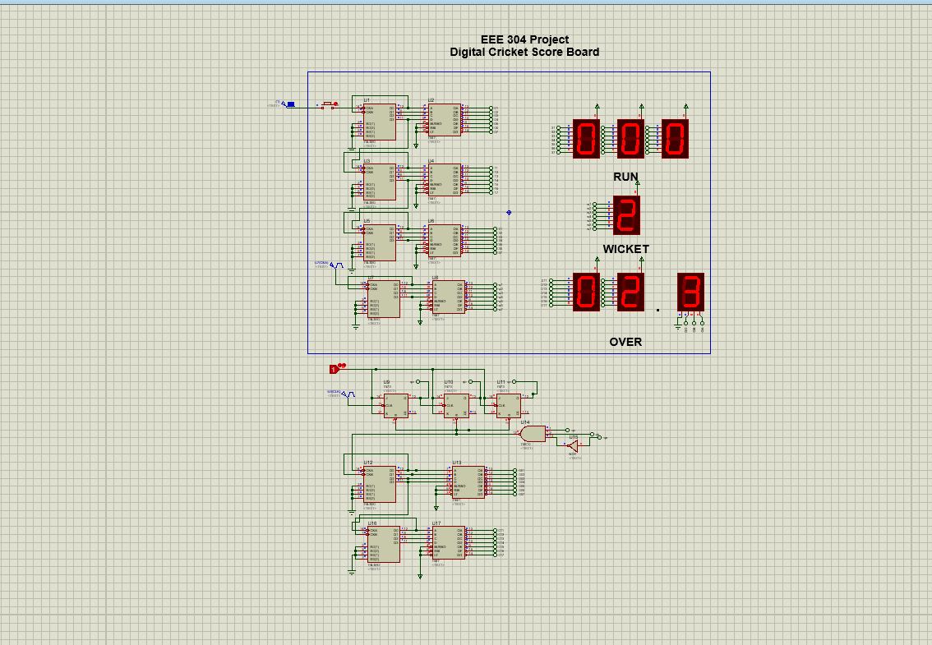

**Fig:** Proteus Simulation of Digital Cricket Scoreboard

1. **Circuit Design Screenshots:**

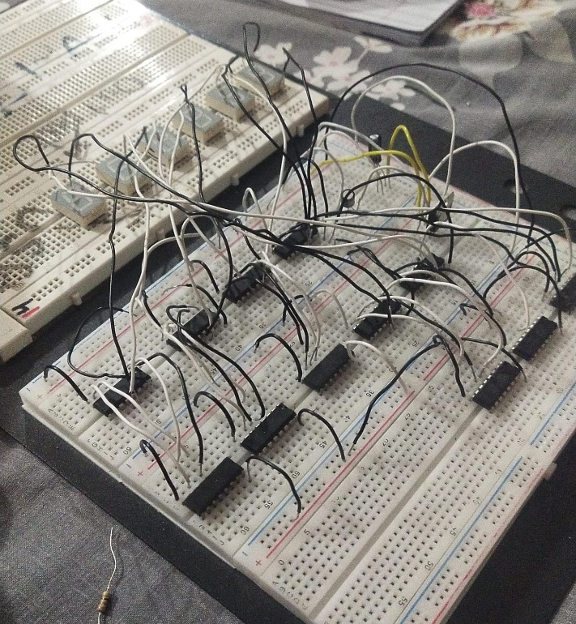

1. **Conclusion:**

Through this project, we learned how to implement digital logic circuits for real-world applications. We used **counters**, **decoders**, and **seven-segment displays** to simulate a working cricket scoreboard. By testing the system on Proteus and breadboard, we gained valuable experience in **circuit simulation**, **troubleshooting**, and **hardware interfacing**. The project helped us deeply understand how digital systems operate and how various logic components interact.

1. **References (Optional):**

* 7490 & 7447 IC datasheets
* 7-Segment display datasheet
* Previous lab materials and logic gate references
* Classroom lectures and slides from DLD course